**Partner with us: Organise a side event**

Tap into the momentum and excitement around the first OECD Local Development Forum in Latin America by organising a side event on 8 or 11 July 2025. These events allow organisers to leverage the visibility and networking opportunities of the Forum, while helping to shape the debate on Forum themes:

|  |  |
| --- | --- |
| * Local economic development * Local employment and skills | * Social economy, inclusion and innovation * Culture, creative sectors and global events |

#### ****About the OECD and its Local Development Forum****

The [Organisation for Economic Co-operation and Development (OECD)](https://www.oecd.org/en.html) is an international organisation dedicated to improving lives through better policies. With over 60 years of experience, the OECD supports policy reform and fosters equality, prosperity, and well-being. Working with more than 100 countries, it provides evidence-based standards, trusted statistics, and a platform for collaborative policy development.

Housed within the [OECD Local Employment and Economic Development (LEED) Programme](https://www.oecd.org/en/about/programmes/leed-programme.html), within the [Centre for Entrepreneurship, SMEs, Regions and Cities](https://www.oecd.org/en/about/directorates/centre-for-entrepreneurship-smes-regions-and-cities.html), the [OECD Local Development Forum](https://www.oecd.org/en/networks/oecd-local-development-forum.html) is a community of thousands of individuals worldwide. Its flagship event is its meeting, convening approx. 400-500 participants from a range of sectors (see chart) and 40+ countries.

The 2025 Forum will take place on the 9-10 July in Barranquilla, Colombia, with side events on 8-11 July. Check out our recent annual meetings to get an idea on what to expect: [Greater Copenhagen, 2024](https://www.oecd-events.org/oecd-local-development-forum-2024)  and [Cork, Ireland, 2022.](https://www.oecd-events.org/local-forum-cork)

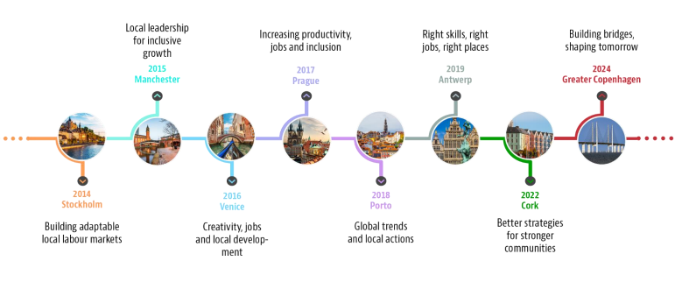

**Previous Annual Meetings**

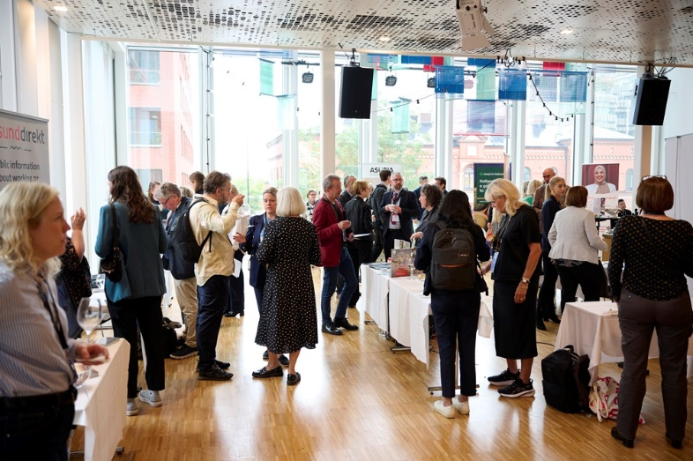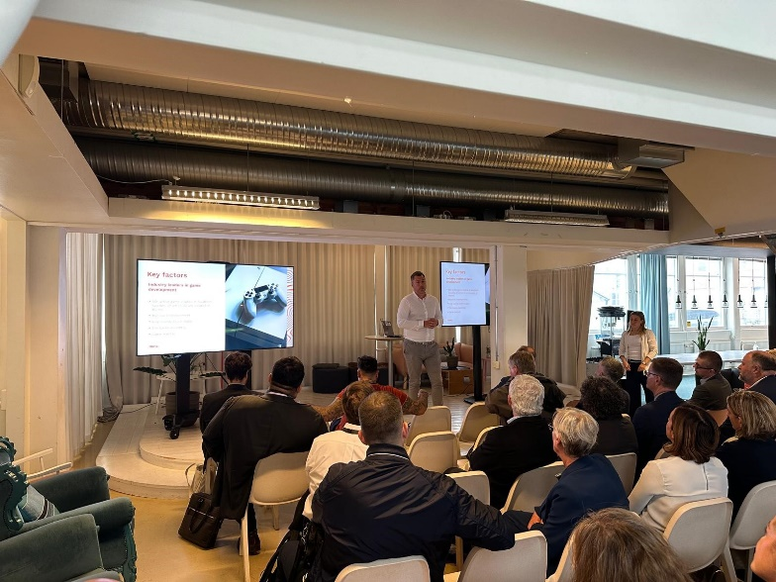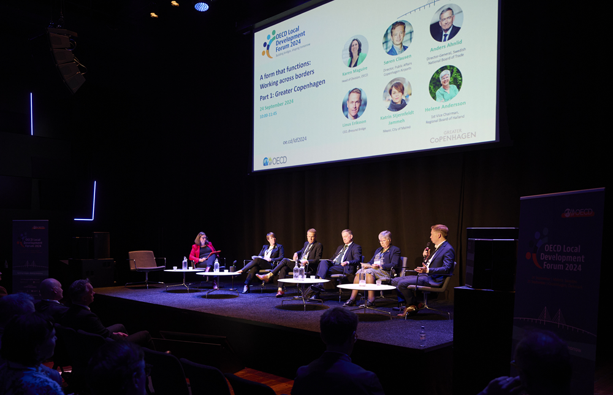

**Why organise a side event with the Local Development Forum?**

* **Get global visibility:** Highlight your best practices, initiatives and research to an international audience.
* **Engage new stakeholders:** Join forces with the Forum to connect with government leaders, private sector representatives, and social innovators, amongst others.
* **Shape the debate:** Bring your perspectives to the global conversation and learn from communities around the world.

**What form can side events take?**

* **Public side events:** Public events are included in the official Forum programme and are open to all Forum participants. The side events are selected by the Forum Secretariat based on their relevance to the Forum themes. The number of these side events are limited.
* **Closed side events:** Organisations can also host closed, invitation-only events for specific audiences, such as working groups, training sessions, or board meetings. These events are not open to general Forum participants but will be featured in the Forum programme and website.

**How are side events organised?**

* **Location:** All side events will be held at the Puerto de Oro Conference Centre on 8 and 11 July 2025.
* **Support provided:** A meeting room, basic audio-visual equipment, and registration services, are included at no cost to the side event organisers. Side events also benefit from being included in the overall Forum communications (website, social media, etc.)
* **Organiser responsibilities:** Side event organisers manage their event’s agenda, speakers, content, and onsite coordination while working with the Forum Secretariat for room allocation and setting. Organisers are directly responsible for all travel and speaker costs.
* **Additional services:** Extra needs like staging, decorations, interpretation, catering, and printing can be arranged upon request at the side event organiser’s expense, followed by direct invoicing.
* **Participant registration:** All attendees, including speakers and moderators, must register for the Forum.

**Want to organise a side event?**

**Submit your expression of interest by 14 February completing the attached form:**

* Include objectives, background and preferred date and time slot (8 or 11 July).
* Describe your promotion plan, speaker suggestions and target audience.

**Have further questions?** Contact [local.forum@oecd.org](mailto:local.forum@oecd.org).

**LOCAL DEVELOPMENT FORUM   
SIDE EVENT EXPRESSION OF INTEREST**

***Please submit to*** [***local.forum@oecd.org***](mailto:local.forum@oecd.org) ***by 14 February 2025***

**Suggested title:**

**Background**

Provide background to the event with key topics to be addressed, including how the event links to the Forum (no more than 200 words)

|  |
| --- |
|  |

**Objectives**

In bullet form, provide a maximum of 3 objectives of the event

|  |
| --- |
|  |
|  |
|  |

**Target audience**

Specify the audience you aim to engage, such as policymakers, private sector representatives, academics, or community leaders. Include ideas for speakers where possible.

|  |
| --- |
|  |

**Format considerations**

|  |  |
| --- | --- |
| **Preferred date and time**  Any time from 9:30-17:00 on 8 and 11 July |  |
| **Duration** |  |
| **Number of participants expected** |  |
| **Additional venue needs**  Note that the meeting room, basic audio-visual equipment, and registration services are included |  |

**Promotion and outreach plan**

Describe how you plan to promote the event and attract attendees.

|  |
| --- |
|  |

**Side event contacts**

|  |  |
| --- | --- |
| Name(s) of organizing institution(s):  (include any partnering organisations) |  |
| Contact person: |  |
| Name: |  |
| Email: |  |
| Phone: |  |

**Any additional information**

|  |
| --- |
|  |