Press Release

Manta5 Launch the anticipated second-generation Hydrofoiler SL3

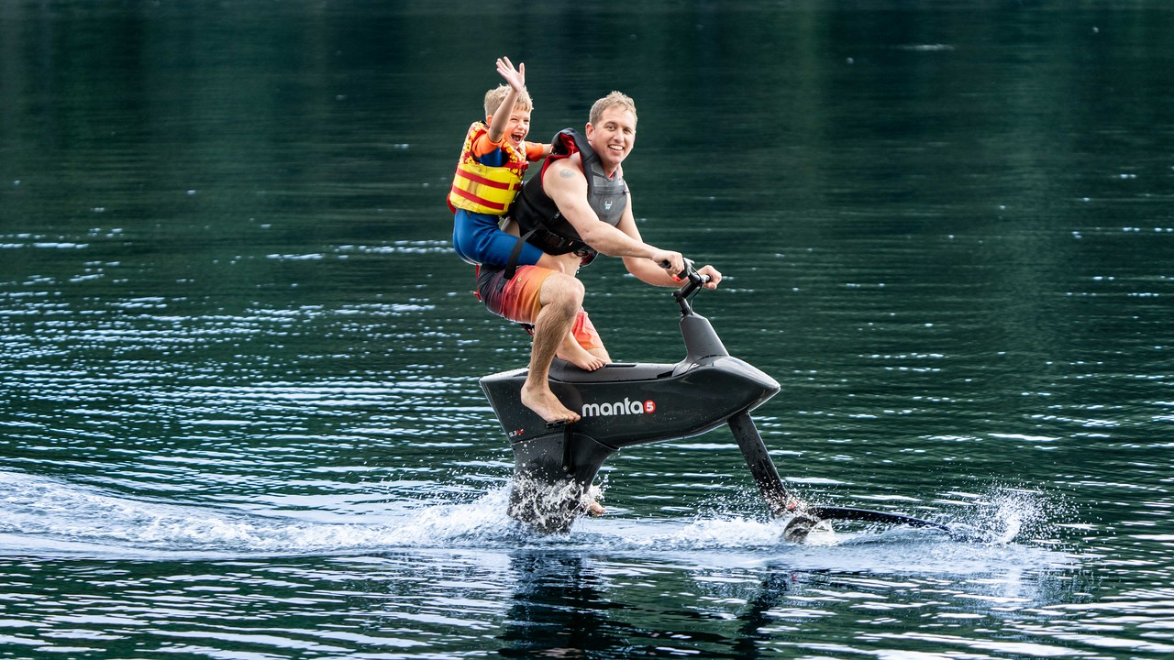

HYDROFOILER SL3 SUMMARY VIDEO (3.14)
FOR HIGH-RES IMAGES AND VIDEO - 2023 PRESSROOM ​​

For more information please contact: louis@manta5.com +642102761476
Manta5 Founder Guy Howard-Willis is available for interview.

June 2023

New Zealand company Manta5 to release the new hydrofoil water bike at Vivatech, Paris 2023.

Vivatech participants will be given the chance to take a first look at the new hydrofoil bike – the Hydrofoiler SL3 at VivaTech (Booth U14). Manta5 are also offering a unique opportunity to personally experience the thrill of riding this new bike on water, just a short distance from the exhibit at Parc nautique départemental - Île de Monsieur.

Please be aware that ride slots are limited. To secure your spot or for more details, please enquire via https://manta5.com/demoevents/ or reach out directly to louis@manta5.com.

Riding the Waves: Manta5 Launches Hydrofoiler SL3, a Must-Try for Cyclists and Water Enthusiasts

The creators of the world’s first hydrofoil bike have now launched the the Hydrofoiler SL3 to be distributed via selected resellers throughout Europe, The US and South America. The SL3’s design and added feature suite place it in the upper echelon of a ‘must try experience’ for any avid cyclist or water sports enthusiast.

The SL3 includes an enhanced throttle-only ride mode that already has the SL3 tipped as a potential jet ski alternative. New riders can progress from novice to competent in minutes rather than hours, unseen before in the category of hydrofoil products.

To replicate the cycling experience on water
The Hydrofoiler SL3 is the result of zero compromise in the pursuit to replicate the intuitive cycling experience we all know and love on land, to the water. To be nimble, fast, able to carve, drift and be close to the action demanded only the most sleek engineering—demonstrating Manta5’s superiority to the pedalo water biking technology of the past.

“Having no hull or pontoon is a welcome trade-off. Just like improving your skills on a land bike it encourages learning and improving, and ultimately to loving every session. Falling off and getting wet when starting out is all part of the fun. Typically with the SL3 it takes less than an hour to go from novice to confident. From there, anyone can add fresh and salt water to their routine. ”, says Mark Robotham, CEO

This experience of cycling on the water is Manta5’s claim to fame. A surreal experience free from trails and traffic. Being able to experience the sensation of flight over the water’s surface at pace while witnessing sea life bursting below, to riding on mirror lakes that reflect the sky above. It is an unparallel experience which needs to be experienced first-hand.

Like all foiling products, when you stop moving, the SL3 will lower until the chassis is floating on the water’s surface. Riders can stay on the saddle semi-submerged when stationary. When it’s time to launch, kick in the throttle or pedal to take off. Very similar to aircraft, the hydrofoil ‘wings’ begin to lift you up higher out of the water the faster you go.

To fly on the water’s surface using hydrofoils requires a substantial amount of power – around 400+ watts continuously. Unless you’re training for the upcoming Tour de France very few can maintain that level of physical output for an extended duration. Combining both human power and a variable electric assist motor has made foil biking possible for the masses, enabling the average rider to adjust the motor assistance as and when they need it. The result is an unprecedented ride time, up to 4.5 hours – the longest ride duration of any e-foiling product on the market today.

When the swell picks up, the new SL3 kicks into gear and turns those conditions into a playground for any thrill seeker. The SL3 competently takes on moving mountains and pierces over and down swell. A guaranteed thrilling experience for advanced riders.

Commercial reliability built into the recreational product
The SL3 is made from carbon fibre and aircraft-grade aluminium, making it buoyant and light enough to carry to the water without the need for a trailer. In addition, a new hardwearing monocoque chassis, structural drivetrain and sealed gearboxes are designed to withstand the harsh marine environment. Dual layer IPX67 battery housings and safety tilt sensors cut motor power as soon as the bike falls are all built into the available models.
“The SL3 was designed with hire operators in mind, and we’ve rolled that through as the standard offering for recreational buyers. For a product to be in the hands of hire and tourism operators it has to be damn near bulletproof” says Head of Product Hayden Reeves.

One of New Zealand’s fasting growing companies
No wake, no emissions, and no noise, coupled with the magic of a surreal flying sensation over the water built a strong community of water riders around the globe with the first generation XE-1 model.
“There’s a hardcore group of super users out there doing some amazing stuff. We’re seeing social clubs and sporting organisations forming, long range channel crossings and footage of on-water experiences that should be on the bucket list for any ardent cyclist.” says Louis Wilks, Head of Marketing

Manta5 says they are well on the way to achieving the goal of building a global brand and creating a new sports category. Since its first prototype went viral in 2018, the subsequent early market success of the first gen XE-1 model the demand to cycle on the water is apparent. As one of New Zealand’s fastest growing company’s Manta5 is fortunate to be able to re-invest heavily in product development.
“Consider the vast range of bicycles on land and consider the potential to recreate these categories on water at various price points. It’s our dream to commoditise foil biking and build a new sport in the process.” says Mark Robotham, CEO.

“I want these bikes to go well beyond just being a leisure product - I want it to be a sports product. If you can race it then it’s competitive, and if it’s competitive then one day it could be an Olympic sport.” - Guy Howard-Willis, Founder & Director of Manta5.

The Hydrofoiler SL3 Is now launched to market and available via authorised resellers. For more information or to learn about upcoming demo opportunities and events visit manta5.com.

New Manta5 Hydrofoiler SL3 Summary
1. 2.5kW motor and throttle
2. 10 levels of pedal assist settings.
3. Introduction of a throttle only launch
4. Up to 4.5-hour ride time
5.. The average new rider can become a confident foil biker in less than 1 hour
6. Modular design breaks the bike down into 5 small pieces for easy in-car transport and assembly waterside
7. Toolless quick connection points for easy assembly
8. Three model variants available at multiple price points. Contact the nearest authorised reseller for a price list

---end

About Manta5
Manta5 created the world’s first Hydrofoil bike and revolutionized the cycling experience on water in 2020. Today, Manta5 leads the world in the innovation of personal hydrofoiling watercraft and champions the growth of emerging hydrofoiling sporting disciplines. Manta5’s product development, marketing, and support is based in Waikato, New Zealand. Manta5 staff are dedicated to making products people love, and to leaving the world better than they found it.

